“Sew” your own Stocking!
In the 19th century, children would hang stockings by the fireplace on Christmas Eve. Most children hung up an everyday sock, hoping to find it filled with fruit, nuts, and sometimes toys and candies in the morning. In the Victorian era, stockings became so popular that factories began producing specially decorated stockings for the holiday. Follow the directions below to cut and ”sew” your own stocking!

What you will need:
Paper
Scissors
Hole punch
Ribbon (about 16 inches in length)

Instructions:
- Print out the stocking below on your chosen paper. If you don’t have access to a printer, you can draw your own stocking pattern to cut out!
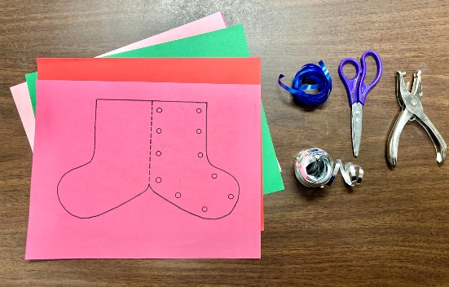
- Cut the stocking out on along the solid black line.
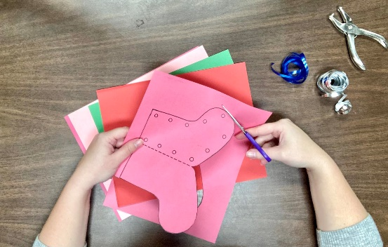
- Fold the stocking along the dotted line.
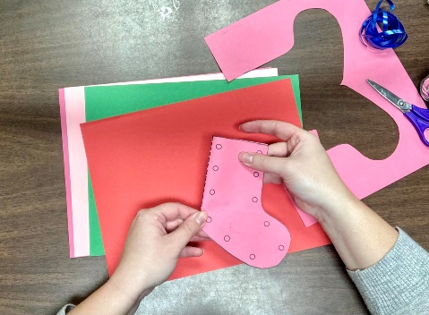
- While the stocking is folded, use a hole punch to cut out the circles. This will create the holes we need to “sew” out stocking up!
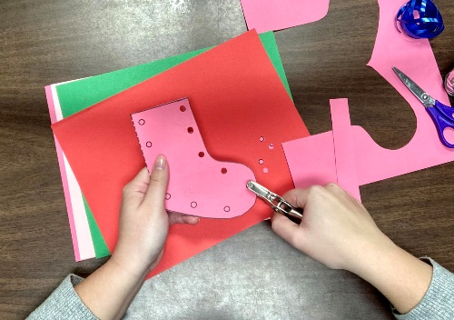
- Insert one end of the ribbon into the top hole punched in the stocking.
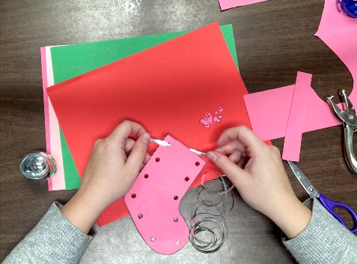
- Insert the ribbon into the hole below, and alternating threading the ribbon in the front and back of the stocking.
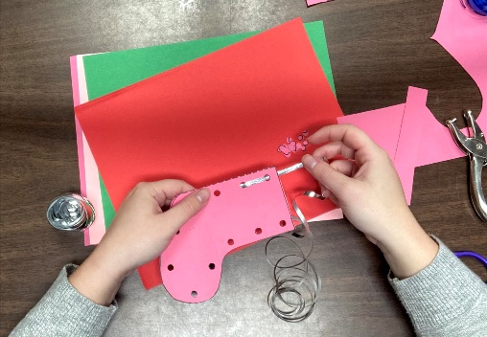
- Continue to weave the ribbon in front of and behind the stocking. Do this until you have sewn the entire stocking together.
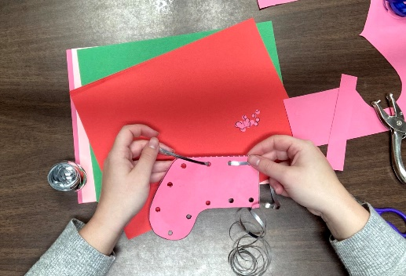
- Tie the two ends of your ribbon together in a bow. You have now completed your stocking!
